

**Patha Pooja Ceremony at Agastya Academy**

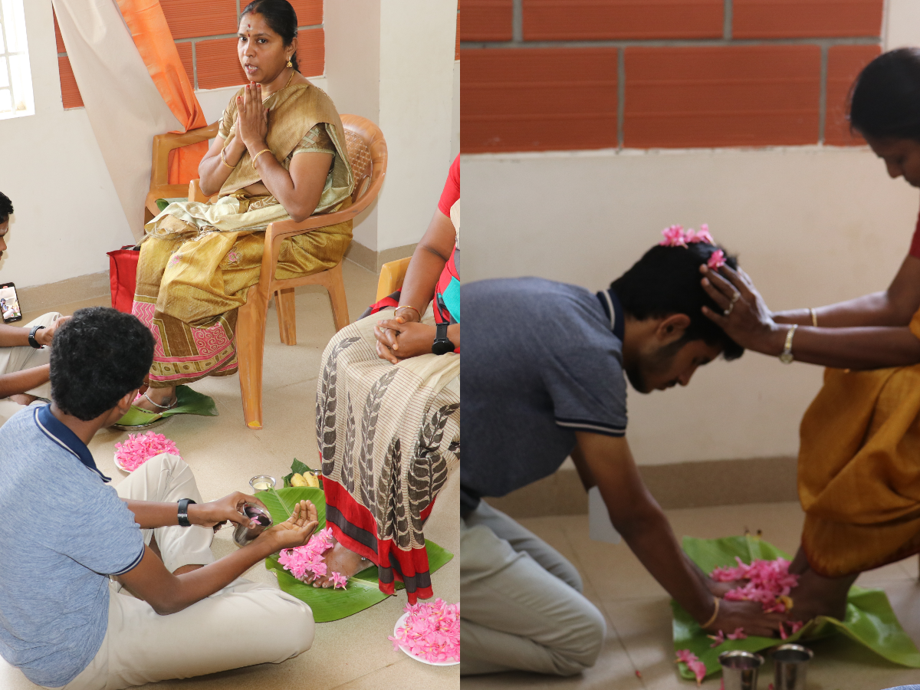

On the morning of January 31, 2024, Agastya Academy was filled with spirituality and gratitude as children performed the Patha Pooja ceremony to seek blessings from their parents.

The day's events followed a sequence of deeply meaningful activities, creating touching moments that resonated emotionally with everyone, the children, parents and teachers.

It was a heartfelt fusion of love, cultural traditions, and academic pursuits, creating a sweet memory for everyone to cherish forever.

[Click here for more....](https://www.agastyaacademy.edu.in/post/patha-pooja-ceremony-at-agastya-academy)